Pankhurst Health Technology Translation Toolkit – Support Network Proforma
To be added to the toolkit’s Support Network, please complete this form and send it to translation-toolkit@manchester.ac.uk. All information will be made publicly available on the toolkit’s website.

Company/Organisation Name

Strapline/ USP
(maximum of 30 words)

How do you support researchers?

At what stage in their research project should a researcher approach you for support?

Contact details  (complete as many fields as you wish) | Company Email:  Website:  Social Media:  Address:  Point of Contact (details of the person within your organisation that queries should be directed to):  Name:  Email address:  Telephone:
Translational stages supported  Cross the boxes of all those that apply, see the Translational Stages diagram (below) for more information on the stages. | ☐D1  ☐D2  ☐D3  ☐D4  ☐T1  ☐T2  ☐T3  ☐T4
If at any point you will need the above information to be updated or would want your data to be removed from the toolkit website, please let us know by email to translation-toolkit@manchester.ac.uk.
In addition to being included in the toolkit, you may also want to create an organisational profile for your company on our Research Connections portal, which is a new tool to enable connections empowering innovation. Research Connections is an online platform that allows users to identify and connect with academic, clinical, and industry experts as well as professional support staff and research technology professionals. Profiles can be discovered through keyword searches linked to areas of expertise, helping others to find you easily. Creating a profile will allow you to showcase your organisation’s offerings and identify potential collaborators who align with your interests. The information required to set up the profile aligns with the details provided above.
Translational Stages
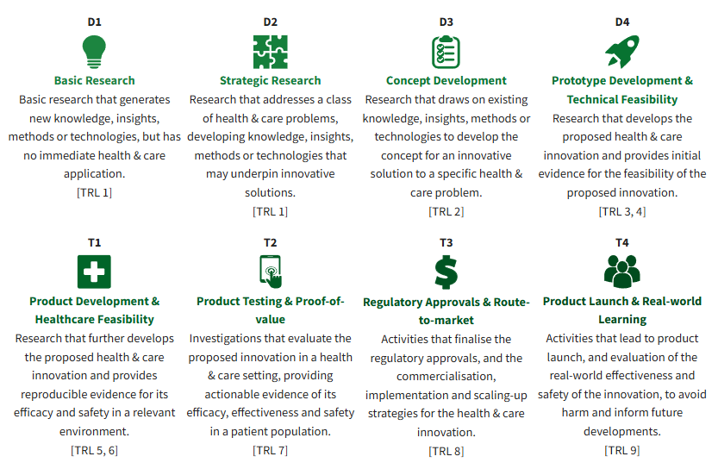

Layout example
